Traffic Flow

🔀 What Is Traffic Flow in Networking?
# Source: AI Source: Provided by: [Data Path: Persons Table -> ID Column: 1, Name_En Column: Motasem Essam] -> From: [ChatGPT] on [12/18/2025]
Traffic flow refers to the movement of data packets between a source and a destination across a network. It represents the pattern, direction, and volume of network communication — often used to analyze performance, security, and capacity.

📦 Belongs to:
# Source: AI Source: Provided by: [Data Path: Persons Table -> ID Column: 1, Name_En Column: Motasem Essam] -> From: [ChatGPT] on [12/18/2025]
✅ Network Analysis & Monitoring Concepts
Along with Bandwidth, Latency, Jitter, and Packet Flow

🧠 Definition:
# Source: AI Source: Provided by: [Data Path: Persons Table -> ID Column: 1, Name_En Column: Motasem Essam] -> From: [ChatGPT] on [12/18/2025]
Traffic flow is the sequence of packets exchanged between two endpoints (e.g., client ↔ server) that share common characteristics — like source/destination IP, ports, and protocol.

📊 Components of a Traffic Flow
# Source: AI Source: Provided by: [Data Path: Persons Table -> ID Column: 1, Name_En Column: Motasem Essam] -> From: [ChatGPT] on [12/18/2025]
A typical flow is defined by these 5-tuple values:
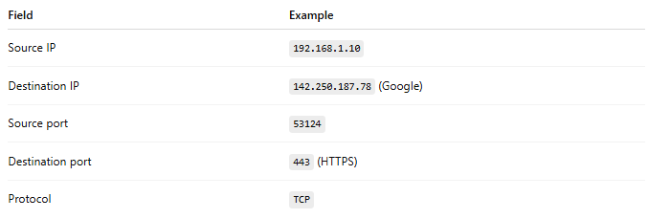
Field | Example
Source IP | 192.168.1.10
Destination IP | 142.250.187.78 (Google)
Source port | 53124
Destination port | 443 (HTTPS)
Protocol | TCP
📌 This combination uniquely identifies a single network session (or flow).

🛣️ Types of Traffic Flows
# Source: AI Source: Provided by: [Data Path: Persons Table -> ID Column: 1, Name_En Column: Motasem Essam] -> From: [ChatGPT] on [12/18/2025]
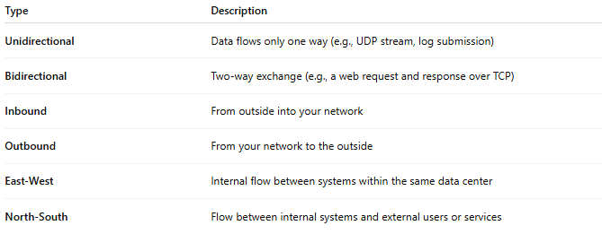
Type | Description
Unidirectional | Data flows only one way (e.g., UDP stream, log submission)
Bidirectional | Two-way exchange (e.g., a web request and response over TCP)
Inbound | From outside into your network
Outbound | From your network to the outside
East-West | Internal flow between systems within the same data center
North-South | Flow between internal systems and external users or services

📡 Example Use Cases
# Source: AI Source: Provided by: [Data Path: Persons Table -> ID Column: 1, Name_En Column: Motasem Essam] -> From: [ChatGPT] on [12/18/2025]
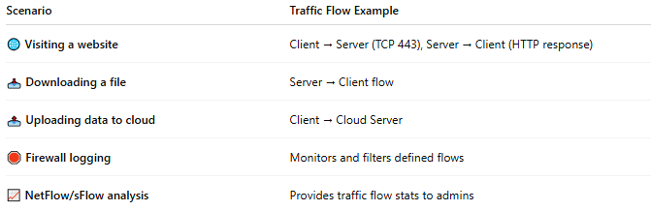
Scenario | Traffic Flow Example
🌐 Visiting a website | Client → Server (TCP 443), Server → Client (HTTP response)
📥 Downloading a file | Server → Client flow
📤 Uploading data to cloud | Client → Cloud Server
🛑 Firewall logging | Monitors and filters defined flows
📈 NetFlow/sFlow analysis | Provides traffic flow stats to admins

🎯 Why Traffic Flow Matters
# Source: AI Source: Provided by: [Data Path: Persons Table -> ID Column: 1, Name_En Column: Motasem Essam] -> From: [ChatGPT] on [12/18/2025]
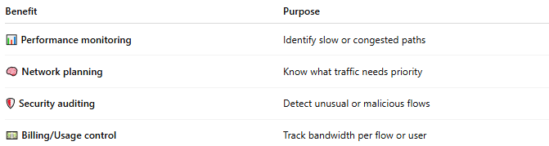

Benefit | Purpose
📊 Performance monitoring | Identify slow or congested paths
🧠 Network planning | Know what traffic needs priority
🛡️ Security auditing | Detect unusual or malicious flows
💵 Billing/Usage control | Track bandwidth per flow or user

📏 How It's Measured
# Source: AI Source: Provided by: [Data Path: Persons Table -> ID Column: 1, Name_En Column: Motasem Essam] -> From: [ChatGPT] on [12/18/2025]
- Flow collectors like NetFlow, sFlow, IPFIX
- Firewalls/routers with traffic logs
- Tools like:
  - Wireshark (deep packet flow analysis)
  - ntopng, SolarWinds, PRTG (flow statistics)
  - nload, iftop, vnStat (live traffic monitoring)

Network Traffic vs Traffic Flow
# Source: AI Source: Provided by: [Data Path: Persons Table -> ID Column: 1, Name_En Column: Motasem Essam] -> From: [ChatGPT] on [12/18/2025]
1. Network Traffic
Network traffic refers to all data moving across a network.
- The amount of data being transmitted
- Can be measured in bytes, packets, or bits per second
- Describes volume and load
Examples:
- Web requests
- Video streaming data
- File downloads/uploads
- Email data
📊 Metrics:
- Bandwidth usage
- Throughput
- Packet rate

2. Traffic Flow
Traffic flow refers to the pattern or path of communication between endpoints.
- A logical stream of packets
- Defined by source IP, destination IP, ports, protocol
- Describes direction and behavior, not volume
Example of a flow:
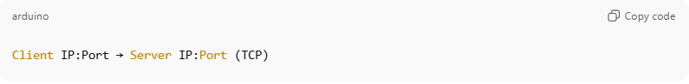
Client IP:Port → Server IP:Port (TCP)
📐 Metrics:
- Latency
- RTT
- Packet order
- Flow duration

Relationship
- Network traffic is the overall data
- Traffic flow is a specific conversation within that traffic
💡 One network can have:
- High traffic volume
- Thousands of individual traffic flows

Real-World Analogy 🚗
- Network traffic = All cars on a highway
- Traffic flow = One specific lane or one car’s trip from A → B

Quick Comparison
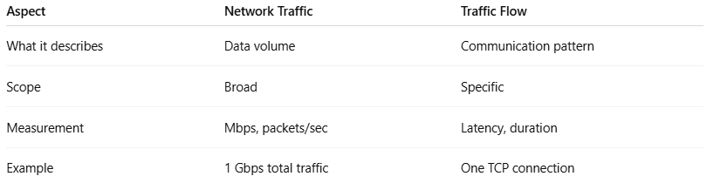
Aspect | Network Traffic | Traffic Flow
What it describes | Data volume | Communication pattern
Scope | Broad | Specific
Measurement | Mbps, packets/sec | Latency, duration
Example | 1 Gbps total traffic | One TCP connection

Key Takeaway
Traffic flow is a part of network traffic, but network traffic is not just a single flow.

📌 Summary
# Source: AI Source: Provided by: [Data Path: Persons Table -> ID Column: 1, Name_En Column: Motasem Essam] -> From: [ChatGPT] on [12/18/2025]
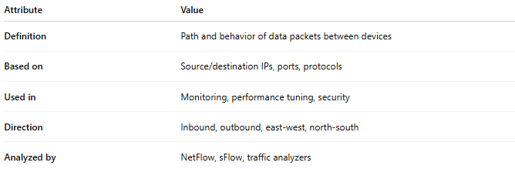

Attribute | Value
Definition | Path and behavior of data packets between devices
Based on | Source/destination IPs, ports, protocols
Used in | Monitoring, performance tuning, security
Direction | Inbound, outbound, east-west, north-south
Analyzed by | NetFlow, sFlow, traffic analyzers

